Study Report
Ⅰ Research background and self-study motivation
1.1 Complex associations in the real world
In the introductory stage of computer science, we primarily encounter linear (such as arrays and linked lists) and tree-like (such as binary trees) data structures. Why did I choose "graph" as my self-study object? I chose "graph" as my self-study object because it possesses strong universality and modeling capabilities. The most frequently used applications of this chapter should be the layout of power lines in China, the distribution of load points, and the direction of power flow, all of which can be perfectly abstracted as vertices and edges of a graph. Therefore, I went online to learn about the knowledge of power systems. Mastering graph theory not only enhances my abstract modeling ability but also provides a theoretical weapon for solving path optimization problems in practical engineering.
1.2 Learning Objectives and Expected Outcomes
This self-study aims to achieve the following three objectives: Firstly, to gain a deep understanding of the Abstract Data Type (ADT) of graphs and their physical storage structures; secondly, to master the classic shortest path algorithm - Dijkstra's algorithm, and comprehend the greedy strategy behind it; finally, through Python programming practice, to compare the impact of different storage structures and algorithm optimization schemes on execution efficiency.

II In-depth Analysis of Graphs
2.1 Mathematical definition and core terminology of graphs (ADT)
A graph (Graph) is a binary pair G = (V, E), where V is a finite non-empty set of vertices and E is a set of edges connecting these vertices. Core terms include: Vertex: represents entities in the network, such as substations. Edge: represents connections between entities, such as transmission lines. Weight: a numerical value attached to an edge, representing cost, distance, or loss. Directed graph and undirected graph: whether the edges have directionality. In the grid model, it is usually regarded as a weighted undirected graph.
2.2 Comparison of physical storage methods for graphs
There are primarily two ways to implement graphs in computer memory: adjacency matrices and adjacency lists. Adjacency matrices use a two-dimensional array of V by V to store the relationships between vertices. Advantages: Intuitive logic, able to determine whether there is an edge between any two vertices with a constant time complexity of O(1). Disadvantages: Space complexity is O(V^2). For sparse graphs (graphs where the number of edges is much smaller than the square of the number of vertices), it can cause significant space waste. Adjacency lists maintain a linked list or array for each vertex that records its neighbor nodes. Advantages: Space complexity is only O(V + E), effectively saving memory. Disadvantages: Checking whether two specific points are connected requires traversing the neighbor list of the corresponding vertices, which is slightly less time-efficient than matrices. Conclusion: When dealing with large-scale sparse networks such as actual physical power grids, adjacency lists are the better engineering choice.
III Algorithm Research - Dijkstra's Shortest Path Algorithm
3.1 Algorithm origin and application scenarios
The Dijkstra algorithm, proposed by computer scientist Edsger W. Dijkstra in 1956, is a benchmark for solving the "single-source shortest path" problem. The core task of this algorithm is to find the shortest path from a specific starting point to all other vertices in a weighted graph. In practical engineering, it is widely used in: GPS navigation systems: finding the shortest distance or least time-consuming route between two locations. Network routing protocols: such as the OSPF protocol, used to determine the transmission path of data packets between Internet routers. Power addressing optimization: in distribution networks, finding the path with the minimum voltage drop or lowest transmission loss.
3.2 Core algorithm logic
Greedy Strategy and Relaxation Operation The essence of Dijkstra's algorithm is a "greedy strategy". It gradually expands to the entire graph by maintaining a set of vertices with determined shortest paths. Its core steps include: Initialization: Set the distance of the source point to 0, and set the distance of all other points to infinity. Selection: Among the nodes that have not been processed, select the point u that is currently closest to the source point. Relaxation: This is the key to the algorithm. For each neighbor v of u, calculate the path length from the source point to v via u. If the length is less than the currently recorded distance of v, update the shortest distance of v. Repeat: Repeat the selection and relaxation steps until the shortest paths of all nodes are locked.
3.3 Performance evolution
From Brute Force Traversal to Binary Heap Optimization In the initial implementation, a simple loop traversal is commonly used to find the node with the minimum distance, with a time complexity of O(V^2). This is acceptable for small networks, but the computational pressure becomes immense for modern power grids with thousands or millions of nodes. Advanced Optimization Solution: Introduce a "Binary Heap" or priority queue. By utilizing the heap structure, the time required to find the minimum value decreases from O(V) to O(log V). Final Complexity: The optimized algorithm has a complexity of O((V + E) log V). This "space-for-time" strategy enables the algorithm to achieve near real-time response on large-scale sparse graphs.

Appendix1
Step-by-Step Walk-through of Algorithm Derivation
Test Graph Construction
To visually demonstrate the algorithm execution process, we construct a weighted undirected graph containing five nodes: A, B, C, D, and E, with the following connections and weights: A to B (weight 4) A to C (weight 2) B to C (weight 1) B to D (weight 5) C to D (weight 8) D to E (weight 2)
Algorithm execution process state table We start with A and record the distance updates of each point at each step:
Step | processing node | The set of path points has been determined | Distance state from A to each point (A, B, C, D, E) | Logical explanation
Initial | - | { } | (0, INF, INF, INF, INF) | Only the starting point is 0
1 | A | {A} | (0, 4, 2, INF, INF) | Update A's neighbors B and C
2 | C | {A, C} | (0, 3, 2, 10, INF) | Select the nearest C. Relax B: A-C-B (3) is shorter than A-B (4), update B
3 | B | {A, C, B} | (0, 3, 2, 8, INF) | Choose B. Relax D: A-C-B-D (3+5=8) is shorter than A-C-D (10), update D
4 | D | {A, C, B, D} | (0, 3, 2, 8, 10) | Choose D. Relaxation E: A-C-B-D-E (8+2=10)
5 | E | {A, C, B, D, E} | (0, 3, 2, 8, 10) | Algorithm ends, all paths have been locked

Analysis of the final shortest distance results
After five rounds of iteration, we obtained the shortest distances from point A: the shortest distance from A to B is 3 (path: A-C-B), the shortest distance from A to C is 2 (directly connected), the shortest distance from A to D is 8 (path: A-C-B-D), and the shortest distance from A to E is 10 (path: A-C-B-D-E). This result clearly demonstrates how the algorithm bypasses direct edges with higher weights (such as A-B) and finds the true global optimal path through transit nodes.
Appendix2
Algorithm source code
The following is the complete code that has undergone logical optimization. The code contains detailed Chinese comments to explain the operational mechanisms of each functional module.
import heapq
import networkx as nx
import matplotlib.pyplot as plt

def dijkstra(graph, start):
# Initialize distances
distances = {node: float('infinity') for node in graph}
distances[start] = 0
# Track previous nodes to find paths later
previous = {node: None for node in graph}

# Priority queue: (distance, node)
queue = [(0, start)]

while queue:
current_dist, current_node = heapq.heappop(queue)

# Skip if we found a longer path
if current_dist > distances[current_node]:
continue

# Check all neighbors
for neighbor, weight in graph[current_node].items():
distance = current_dist + weight

# If we found a shorter path, update it
if distance < distances[neighbor]:
distances[neighbor] = distance
previous[neighbor] = current_node
heapq.heappush(queue, (distance, neighbor))

return distances, previous

def draw_graph(graph, distances, previous, start):
# Create graph
G = nx.DiGraph()

# Add all edges
for node in graph:
for neighbor, weight in graph[node].items():
G.add_edge(node, neighbor, weight=weight)

# Set position for nodes
pos = nx.spring_layout(G, k=3, seed=42)

# Create figure
plt.figure(figsize=(15, 6))

# ===== LEFT: Original graph =====
plt.subplot(1, 2, 1)
plt.title("Power Grid", fontsize=14, fontweight='bold')

# Draw nodes
nx.draw_networkx_nodes(G, pos, node_color='lightblue', node_size=2000)
nx.draw_networkx_nodes(G, pos, nodelist=[start], node_color='red', node_size=2500)

# Draw edges
nx.draw_networkx_edges(G, pos, edge_color='gray', arrows=True, arrowsize=20)

# Add edge labels (weights)
edge_labels = nx.get_edge_attributes(G, 'weight')
nx.draw_networkx_edge_labels(G, pos, edge_labels=edge_labels, font_size=10)

# Add node labels
labels = {node: f"{node}\n{distances[node]}" for node in G.nodes()}
nx.draw_networkx_labels(G, pos, labels=labels, font_size=9)

plt.axis('off')

# ===== RIGHT: Shortest paths =====
plt.subplot(1, 2, 2)
plt.title("Shortest Paths from " + start, fontsize=14, fontweight='bold')

# Draw everything in gray first
nx.draw_networkx_nodes(G, pos, node_color='lightgray', node_size=2000, alpha=0.3)
nx.draw_networkx_edges(G, pos, edge_color='lightgray', arrows=True, arrowsize=20, alpha=0.3)

# Find all shortest path edges
path_edges = []
for node in G.nodes():
if node != start and previous[node] is not None:
path_edges.append((previous[node], node))

# Draw shortest paths in red
if path_edges:
nx.draw_networkx_edges(G, pos, edgelist=path_edges, edge_color='red',
width=3, arrows=True, arrowsize=25)

# Draw nodes on shortest paths in green
path_nodes = set([start])
for edge in path_edges:
path_nodes.add(edge[0])
path_nodes.add(edge[1])

nx.draw_networkx_nodes(G, pos, nodelist=list(path_nodes),
node_color='lightgreen', node_size=2000)
nx.draw_networkx_nodes(G, pos, nodelist=[start], node_color='red', node_size=2500)

# Add labels
nx.draw_networkx_labels(G, pos, labels=labels, font_size=9)
nx.draw_networkx_edge_labels(G, pos, edge_labels=edge_labels, font_size=10)

plt.axis('off')

# Add simple legend
from matplotlib.patches import Patch
legend_elements = [
Patch(facecolor='red', label='Start (Substation)'),
Patch(facecolor='lightgreen', label='On shortest path'),
Patch(facecolor='lightblue', label='Other nodes'),
plt.Line2D([0], [0], color='red', linewidth=3, label='Shortest path')
]
plt.legend(handles=legend_elements, loc='upper right', fontsize=9)

plt.tight_layout()
plt.show()

# Print results simply
print("\n" + "="*50)
print("SHORTEST PATHS FROM", start)
print("="*50)
for node in sorted(distances):
if node != start:
# Build path
path = []
current = node
while current is not None:
path.append(current)
current = previous[current]
path.reverse()

path_str = " → ".join(path)
print(f"To {node}: distance = {distances[node]}, path: {path_str}")

# ===== TEST GRAPH =====
# Simple power grid example
power_grid = {
'Substation': {'Node1': 10, 'Node2': 5},
'Node1': {'Node3': 1, 'Substation': 10},
'Node2': {'Node1': 2, 'Node3': 9, 'Node4': 2, 'Substation': 5},
'Node3': {'Node4': 4, 'Node1': 1, 'Node2': 9},
'Node4': {'Node2': 2, 'Node3': 4}
}
# ===== RUN =====
print("Finding shortest paths...")
distances, previous = dijkstra(power_grid, 'Substation')
draw_graph(power_grid, distances, previous, 'Substation'
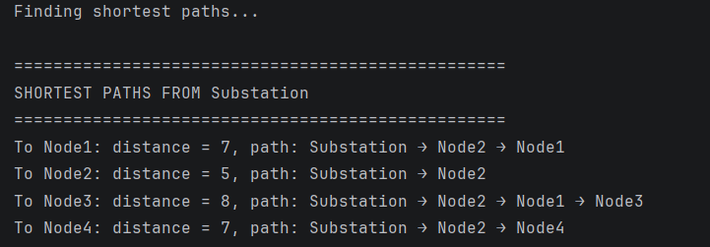
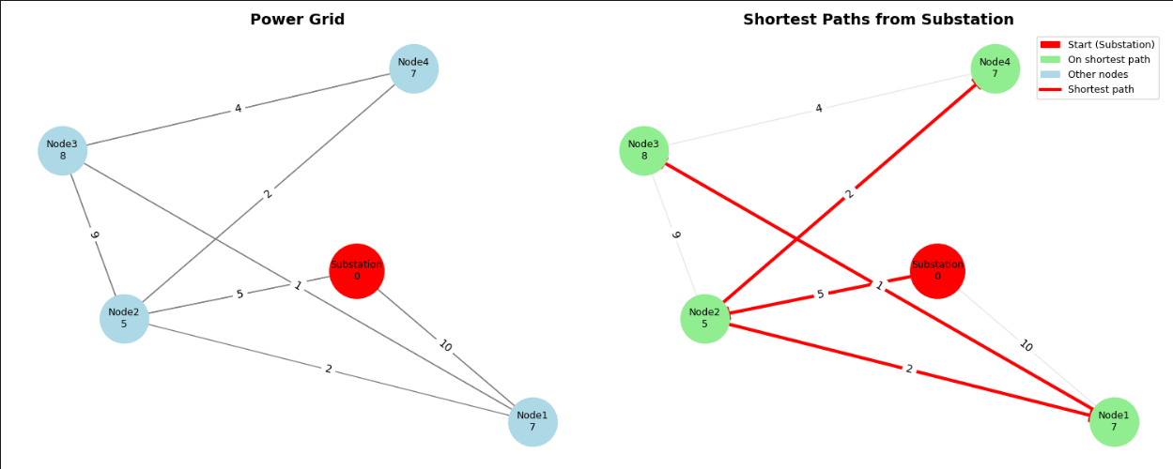

Appendix3
Self-study Experience and Summary
Improvement in Abstract Modeling Ability Through this self-study of the "graph" data structure, I have deeply realized that the intricate physical networks in reality (such as power lines and fiber optic topologies) can be highly abstracted into vertices and edges in mathematics. This modeling ability is the first and most crucial step in solving practical engineering problems.
Space for Time: Reflections on Algorithm Efficiency When learning about the comparison between adjacency matrices and adjacency lists, as well as the differences between brute-force traversal and heap optimization, I realized the significance of "algorithmic complexity" in engineering practice. When dealing with data involving a large number of nodes, such as distribution network planning, even a slight improvement in algorithm efficiency can lead to a significant reduction in computation time.
Future Advancement Direction Although the Dijkstra algorithm is powerful, it becomes ineffective when dealing with graphs with "negative edge weights". In my future studies, I plan to further investigate the Bellman-Ford algorithm or SPFA algorithm to cope with more complex engineering environments. At the same time, I also hope to combine graph theory algorithms with the indexing mechanisms of vector databases (such as Milvus) that I am currently researching, exploring broader applications in the AI field.

